

Legislative Council

November 08, 2012 |  | 77LCB21 – Brand and Identity
Sponsored by: | Alexander Zeke Johnson | Legislative Council Vice-President
 | Logan Schlutz | Tri-Executive
 | J. Benjamin Leeds | Representative Council Speaker
Authored by: | J. Benjamin Leeds | Representative Council Speaker

A Bill

Bill History

In the year 2000, a bill (52LCB04) was passed that officially selected a logo of the University of Colorado Student Union. Since that time, new brand and identity standards at the system level and a name change to University of Colorado Student Government (CUSG) have been implemented, rendering the 2000 logo obsolete.

The system-wide brand and identity standards development initiative stemmed from recognition that CU was presenting itself internally and externally in a fragmented, ineffective, and inefficient manner. Thus, CU engaged branding firm Landor Associates to work with a team comprised of the president, chancellors, CU Foundation leadership, and lead communication staff system-wide. This team conducted surveys, interviews, and other research to develop the key messages and visual images in place today.

Bill Summary

In light of the name change to University of Colorado Student Government and the implementation of new brand and identity standards for entities system-wide, this bill repeals and nullifies 52LCB04¹ and implements a new logo and brand identity scheme for the University of Colorado Student Government. This bill enforces the use of University of Colorado System Identity Standards, University of Colorado Boulder Identity Standards, especially one logo and its respective variations that must be used in all communications of the University of Colorado Student Government. Additionally, this bill seeks to improve awareness amongst University of Colorado Student Government staff members of system-wide brand and identity standards in general.

Whereas, the University of Colorado implemented Identity Standards for all University of Colorado entities of which the University of Colorado Student Government is not yet fully compliant.

Whereas, it is of utmost importance that any organization use one consistent logo and visual identity in the entirety of their communications materials to further recognition of their organization and streamline their messages.

Whereas, a consistent visual identity will serve to quickly identify official communications of the University of Colorado Student Government.

THEREFORE BE IT ENACTED by the Legislative Council of the University of Colorado Student Government, THAT,

SECTION 1: Repeal of Previous Legislation

52LCB04¹ is hereby repealed and nullified in its entirety. 52LCB04¹ implemented a process to select an official logo of the University of Colorado Student Union.

SECTION 2: Compliance with System and Campus Brand and Identity Standards

- The University of Colorado Student Government and its three (3) branches shall be in compliance with the entirety of the University of Colorado Identity Standards and University of Colorado Boulder Identity Standards (herein referred to as “Standards”). The provisions of this legislation do not supersede and are secondary to both aforementioned documents.

- Legislative Council recommends the inclusion of the following statement or its equivalent in job descriptions of future CUSG staff members: “Staff members of the University of Colorado Student Government shall be familiar with and follow the guidelines of the University of Colorado and University of Colorado Boulder Identity Standards”

SECTION 3: Required Uses of Brand and Identity Standards

Any and all University of Colorado Student Government communications, documents, and materials including but not limited to the following shall be compliant with the Standards and use ONLY those approved logos shown in Appendix A.

- Governing Documents
- Legislation (bills or resolutions) of the Legislative Council, Representative Council, and Council of Colleges and Schools
- Minutes and Agendas of the Legislative Council, Representative Council, Council of Colleges and Schools, Finance Board, and Student Group Funding Board
- Any and all official communications of the Legislative, Executive, and Judicial branches
- Any and all official communications to University Administration, faculty, staff, cost centers, and student organizations
- Any and all official communications to the Board of Regents, State Legislature, City of Boulder Government, and/or any other governmental entities in the United States of America and abroad
- Any and all University of Colorado Student Government promotional materials including but not limited to:
  - Apparel / Clothing
  - Nametags / Placards
  - Pens, Water Bottles, Stickers, etc.
- Any and all University of Colorado Student Government electronic communications including but not limited to:
  - Website(s)
  - Blog(s)
  - Facebook Page(s)
  - Email Correspondence Signatures (all staff members from all three (3) branches) for those who have email addresses created solely for CU Student Government use (eg. cusg.president@colorado.edu)
  - PowerPoint Presentations
- Any and all University of Colorado Student Government printed materials including but not limited to:
  - Business Cards
  - Letterhead
  - Forms
  - Reports
  - Budgets
  - Explanatory Documents
  - Flyers (event or otherwise)
  - Materials promoting CU Student Government elections by the Election Commission (not to be construed to include materials produced by tickets, candidates, and/or political parties in furtherance of a campaign)

SECTION 4: Communication of Bill Provisions to CU Student Government

The requirements of this legislation shall be widely communicated to all CU Student Government staff members and be included as part of the orientation of new members. In the interests of efficiency and ease of transition, a summary document outlining the Standards will be created and distributed to CUSG staff. Additionally, it shall be the responsibility of the CU Student Government Office Manager to ensure these requirements are communicated through administration transitions (especially to the Director of Communication or their equivalent).

SECTION 5: Special Cases

In the event compliance with this legislation raises concerns of the following nature (one or more):
- Increased Cost (eg. Use of logo on a promotional pen as opposed only using the words “University of Colorado Student Government”)
- Lack of Sufficient Space (eg. Use of logo on nametags)

The person(s) working on the project may request a deviation from the provisions of this legislation by majority approval of the following three (3) CU Student Government officials:
- One of the Executives (or their designee)
- Director of Communication
- President of Legislative Council (or their designee)

SECTION 6: Use of Existing Materials

This legislation applies to any and all communications and materials physically produced after its passage. Existing materials may continue to be used until they are depleted.

SECTION 7: Implications to Cost Centers and Student Organizations

This legislation does not apply to Cost Centers of the University of Colorado Student Government (except CUSG Proper and Student Group Funding Board) or Student Organizations registered with the Student Organizations Finance Office.

SECTION 8: Executive Veto

This bill shall take effect upon passage by the Legislative Council and upon either obtaining the signatures of two (2) Tri-Executives or the lapse of six (6) days without action by the Tri-Executives.

11/08/2012 | Passed 1st Reading | Acclamation
11/15/2012 | Passed 2nd Reading | Acclamation

Brittni Hernandez  Tri-Executive | Colin Sorensen  Legislative Council President
Tyler Quick  Tri-Executive | Logan Schlutz  Tri-Executive

SECTION 9: Sponsor Signatures

Zeke Johnson  Legislative Council Vice-President | Logan Schlutz  Tri-Executive
J. Benjamin Leeds
Representative Council Speaker

Appendix A:
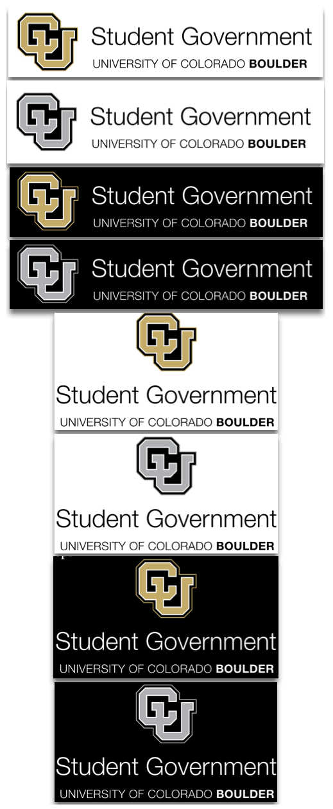

52 Legislative Council Bill #4 [http://cusg.colorado.edu/sites/default/files/bill-db/52LCB04.pdf]
University of Colorado Identity Standards [https://www.cusys.edu/branding]
University of Colorado Boulder Identity Standards [http://brand.colorado.edu]

