Bill Status: PASSED

Student Governmen1

UNIVERSITY OF COLORADO BOULDER

University of Colorado Student Government
Legislative Council

Date |  | 84 LCB 06 -Outlook CUSG
Sponsored by:  Authored by: | Joseph Soto  Joseph Soto | President of External Affairs  President of External Affairs

A Bill to Use Microsoft Outlook for CUSG Business

Bill History

Previous legislation encouraged CUSG to utilize Gmail for CUSG-related work. Previous administrations have tried to switch us to Outlook with no success. This year, the Tri-Executives began discussions about switching CUSG email use to Outlook from Gmail, but that never came together as other things took more salience in their agenda. After hearing about concerns over transparency and wanting to remain as transparent in everything as possible, this bill is being presented to Legislative Council.

Bill Summary

This bill mandates that CUSG switch to Microsoft Outlook to handle all CUSG Proper­
related business.

Whereas, transparency is one of the most important qualities of any organization;

Whereas, Microsoft Outlook allows for more transparency by automatically archiving emails;

Whereas, automatic archiving is important to making sure future students and others are able to look back at the totality of any CUSG Proper action, including emails and communication;

THEREFORE, BE IT ENACTED by the Legislative Council of the University of
Colorado Boulder Student Government, THAT:

Section 1: The CUSG Tri-Executives for the 2015-2016 school year will begin the process of creating emails for CUSG Proper through Microsoft Outlook with the support ofOIT.

Section 2: The CUSG Tri-Executives for the 2016-2017 school year as well as the CUSG Office Manager will actively support the implementation of Microsoft Outlook as the means for communication for all CUSG Proper-related business.

Section 3: Beginning when the CUSG Tri-Executives for the 2016-2017 school year assume office, Microsoft Outlook will be the only communication tool used for CUSG Proper-related business.

Section 4: The bill shall take effect upon final passage in Legislative Council and upon either obtaining the signature of two Tri-Executives and the Legislative Council President or the lapse of six days without action by the Tri-Executives.

Vote Count:

04/14/15
04/21/15
Approved on 1st reading
Passed on 2"d reading
12·2·1
12·2·1

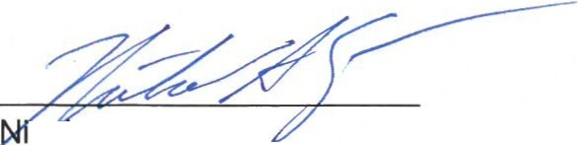co as Trevino
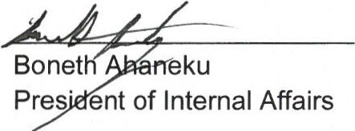Legislative Council President
Lurquin
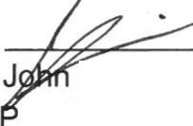resident of Student Affairs

President of External Affairs

