Bill Status: Passed

Student Governmen1

UNIVERSITY OF COLORADO BOULDER

University of Colorado Student Government
Legislative Council

Date: 03/04/2016 84 LCR 02 - Support for Revising Occupancy

Sponsored by: Joseph Soto President of External Affairs

Authored by: Adli Ahram Director of City and Neighborhood
Relations

Ted Koenig
Melissa Ugelow
Student at large
Student at large

A Resolution in Support of Revising Occupancy Limitations

Resolution History

In fall 2015, Boulder City Council voted for increased enforcement powers for the existing occupancy limits. City Council unanimously made this decision in the face of CUSG and groups' efforts against its passage. Boulder Choices for Boulder Homes originally sought to work with City Council members to pursue a resolution that considered the needs of residents, but this was to no avail. In light of this decision, Boulder Choices for Boulder Homes decided that the issue at hand was changing the housing limits rather than focusing on enforcement. We have sought to open and maintain contact with council members and interested parties with some success. From these conversations our group has gathered that there is little prospect of legislative action from the city on the matter in the near future. Currently, we are maintaining open channels and are always open to a legislative solution. A voter initiative is the only remaining remedy available to deliver change on an acceptable timetable. We have been partnering with members of CUSG on our initiative.

In formulating the language of the initiative, we have sought a simple and reasonable rule which Boulder residents would widely and enthusiastically support. We believe the resulting proposed rule fits these criteria. In discussions and survey feedback, we were encouraged to specifically tackle a number of complaints such as parking, nuisances, and cost. We examined adding language in the resolution for each of these. Occupancy limits represent a blunt, ineffective, and destructive tool to tackle problems associated with density. As resolved in the fall, specific remedies exist for these problems and to tackle them through occupancy limits is to criminalize people rather than actions. Moreover, the current numeric limits make no reference to the specifics of a property. This is a fundamental flaw. This will decriminalize

the residence of persons whose only infractions are against the current low occupancy limits. Counting bedrooms and bathrooms may be a simplistic approach, and the city must craft a better solution in the future.

Resolution Summary

The summary of this bill is to solidify that our main intentions are to focus on defining the housing limits. The purpose is to support reasonable zoning standards in Boulder. Furthermore, we want to work with the Boulder City Council to properly assign property rights which are to the benefit of all. Finally, we want to address this issue in conjunction with the permanent residents of Boulder to find a sustainable solution.

THEREFORE, BE IT RESOLVED by the Legislative Council of the University of
Colorado Boulder Student Government, THAT:

Section 1: The resolution supports modifying the current occupancy limits to more accurately reflect the living conditions of a given housing unit.

Section 2: The resolution supports fostering a more constructive working relationship with city council in the hopes that we can find a solution to this problem with wide ranging support.

Section 3: The resolution supports the efforts to change occupancy limits in Boulder of
Boulder Choices for Boulder Homes.

Section 4: The resolution shall take effect upon final passage in Legislative Council and upon either obtaining the signature of two Tri-Executives and the Legislative Council President or the lapse of six days without action by the Tri-Executives.

Vote Count:

03/10/2016
03/17/2016
03/17/2016
Approved on 1st reading
Amended "Bolder" to "Boulder" Passed on 2"d reading
15-0-1
Acclamation
Acclamation

1colas Trevino
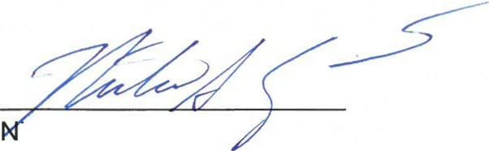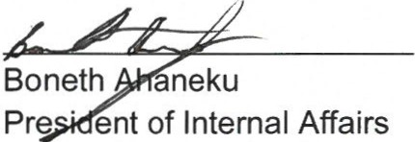Legislative Council President
urquin
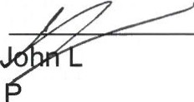resident of Student Affairs

a-
President of External Affairs

