Resolution Status: PASSED

Student Governmen1

UNIVERSITY OF COLORADO BOULDER

University of Colorado Student Government
Legislative Council

Date: 03/04/2016 84 LCR 07- Support of House Bill16-1420

Sponsored by: Joseph Soto President of External Affairs

Authored by: Jon Heisler
Ethan Armitano
Co-Director of Legislative Affairs
Co-Director of Legislative Affairs

A Resolution in Support of House Bill 16-1420

Resolution History
In the state of Colorado there is a constitutional amendment called the Tax Payer Bill of Rights (TABOR). Under TABOR fiscal spending cannot exceed particular cap that is indexed for inflation, population growth, and the previous year's spending. If revenues are larger than what the state government can spend, a refund to the tax payers occurs. Certain aspects of the state budget are designated to be counted under the TABOR cap and other aspects of state spending are exempted from the TABOR limit. One of the fiscal spending programs that Colorado counts under the TABOR limit is its investment
in hospitals. Colorado collects a tax for the purpose of allocating towards state hospitals. The state is heavily in the operation of these hospitals in terms of regulation and actual control. House Bill 16-1420 changes this tax in the legal code into an enterprise fee. This would exempt the revenue collected from the TABOR limits. Without the passage of HB 16-1420 the state budget allocation will fall by $350 million and many of these cuts come directly from education, roads, and other services. With the passage of HB 16-1420 the tax payers stand to lose a refund projected at $25 this year and as high as $125 next year. Lawmakers who support the bill have stated that their intention
is to spend some of the money on higher education. Additionally, automatic transfer to the states Highway User's Tax Fund and Capital Construction Fund will occur. The last aspect of the bill is establishing a state accountability board for state hospitals.

Resolution Summary
This resolution is in support of the passage of HB16-1420 for the purpose of freeing up more money in the state's budget under the TABOR cap. This resolution supports the change of the Hospital Provider Fee to exempt it from TABOR limits.

THEREFORE, BE IT RESOLVED by the Legislative Council of the University of
Colorado Boulder Student Government, THAT:

Section 1: The resolution supports House Bill 16-1420 CO Healthcare Affordability & Sustainability Enterprise.

Section 2: The resolution shall take effect upon final passage in Legislative Council and upon either obtaining the signature of two Tri-Executives and the Legislative Council President or the lapse of six days without action by the Tri-Executives.

04/21/16
Vote Count:
SpecialOrder Passed on 1st reading Acclamation

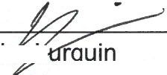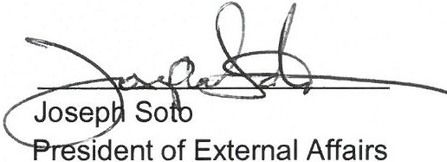Legislative Council President

