Resolution Status: PASSED

Student Governmen1

UNIVERSITY OF COLORADO BOULDER

University of Colorado Student Government
Legislative Council

Date 4/18/2016 84LCR08 - Support of the CUSG Helmet Program

Sponsored by: Joseph Soto Boneth Ahaneku John Lurquin
Shannon Lacy

President of External Affairs President of Internal Affairs President of Student Affairs
CUSG Chief of Staff

Authored by:
Joseph Soto President of External Affairs

A Resolution in Support of the CUSG Helmet Program

Resolution History

Charlie Mintz of Freshman Council first mentioned the idea for a helmet program sponsored by CUSG during Freshman Council Retreat in Fall 2015. He worked on this idea for the 15-16 academic year, working with the Tri-Executives and folks in Wardenburg and the community. These meetings really illuminated the problem of students suffering concussions on our campus, and showed the space that CUSG can occupy to try to solve that problem and allow for greater CUSG outreach in the process.

This bill serves to protect the program by giving it legitimacy and encourages its growth for the future.

Resolution Summary

This resolution celebrates the CUSG Helmet Program in its pilot year, and encourages CUSG to support this program and others that find innovative ways to combine CUSG outreach and well-being efforts.

Whereas, health and well-being are important components of a student's overall experience in college;
Whereas, many students at CU Boulder choose to ride on bicycles or skateboards to get around the city and campus;
Whereas, helmets are crucial for people riding or driving any motor vehicle or bike, especially bicycles and skateboard;
Whereas, not wearing a helmet while riding a bicycle or skateboard drastically increases one's risk of sustaining a traumatic brain injury (TBI) in the unfortunate event of an accident;
Whereas, 394 students have gone through Wardenburg's concussion protocols this academic year;
Whereas, students who go through Wardenburg's concussion protocols are not given helmets to protect their head in the future;
Whereas, CUSG ought to be able to step in and support low-cost, innovative programs like this as it provides for the betterment of students and allows CUSG to conduct outreach as well;

THEREFORE, BE IT RESOLVED by the Legislative Council of the University of
Colorado Boulder Student Government, THAT:

Section 1: CU Student Government supports and celebrates the CUSG Helmet Program as a meaningful opportunity for CUSG to deepen its ties with the Wardenburg community.

Section 2: CU Student Government commends Charlie Mintz from Freshman Council for coming up with this idea and working hard on it all academic year, and CUSG Chief of Staff Shannon Lacy for managing Freshman Council.

Section 3: CU Student Government encourages student leaders and others to continue to find innovative ways to combine education about CUSG with health and well-being efforts on campus.

Section 4: The resolution shall take effect upon final passage in Legislative Council and upon either obtaining the signature of two Tri-Executives and the Legislative Council President or the lapse of six days without action by the Tri-Executives.

Vote Count:

4/21/16
4/28/16
1st reading
2"d reading
Acclamation
Approved

/)
2/
Legislative Council President

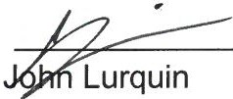President of Student Affairs

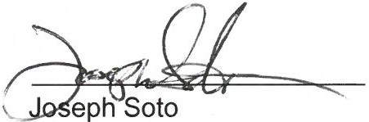
President of External Affairs

